First Aid Summary Sheet

This sheet should be displayed near first aid kits, in first aid room/sick bay and on notice boards

General

location address: 1 Crestdale Road, Wantirna, 3152

nearest cross street: Birchfield Crescent, Wantirna 3152

location of first aid room: Main Building, Opposite General Office

Victorian Poisons Information Line

Available 24 hours a day, 7 days a week on 13 11 26 or call 000 in an event of an Emergency.

First Aid Officers – Completed Provide First Aid (HLTAID011)

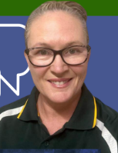 |  |  |  | 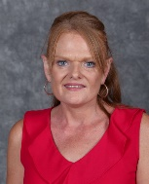 |  |  | 
Kristi Disney  First Aid Room  EXT 128 | Carolyn Che  First Aid Room  EXT 128 | Marc Crilly  Assistant Principal Office  EXT 104 | Rod McKinlay  Principal Office  EXT 103 | Andrea Edwards  Assistant Principal Office  EXT 102 | Pam Raines  Main Office  EXT 100 | Trudy O’Neil  Main Office  EXT 129 | Deb Morrison  Prep  EXT 131

Warden/Incident Controllers
Name: | Rod McKinlay, Principal | Work location: | Principal’s Office EXT 103
Name: | Marc Crilly, Assistant Principal | Work location: | Assistant Principal’s Office EXT 104
Name: | Andrea Edwards, Assistant Principal | Work location: | Assistant Principal’s Office EXT 102

Evacuation Assembly Point (at least 200 metres away from work area)

Bottom Oval

Nearest Medical Centre | Nearest Hospital
Harold Street Medical Centre  Telephone: 9800 2088 & 9887 3039  Address: 103 Harold Street, Wantirna | Knox Private Hospital  Telephone: 9210 7000  Address: Mountain Hwy, Wantirna

Incident Support Operations Centre (ISOC)
Available 24 hours a day, 7 days a week on 1800 126 126

