

Community Conduct

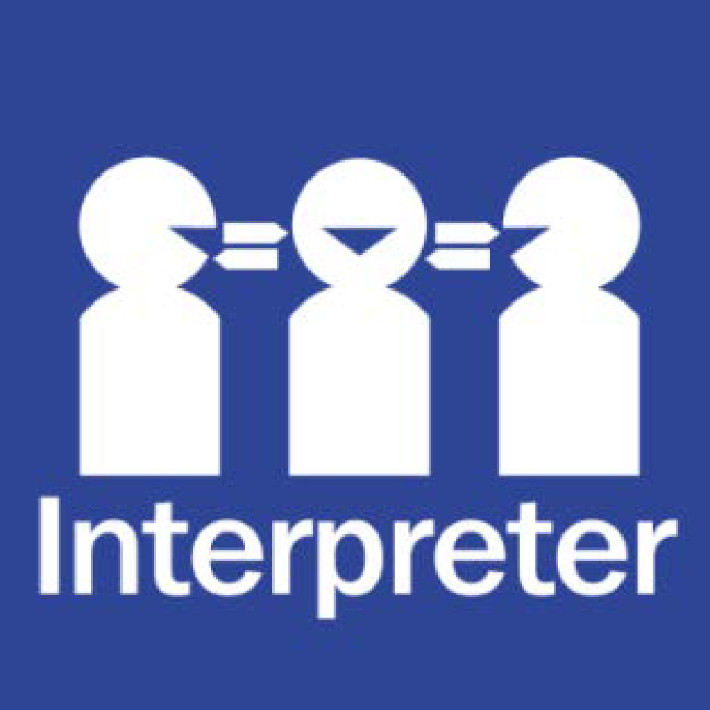
Help for non-English speakers.
If you need help to understand the information in this policy, please contact Xiaomei Lin 98017450

Rationale

Templeton Primary School recognises the importance of parental support and involvement in the school. The basis of relationships between all members of the school community (the staff, children, and parents) will be one of mutual respect.
Aim

To ensure that all school community members understand and support the school’s position in relation to standards of behaviour.

Implementation

Staff at Templeton Primary School, including teachers, education support staff, office staff, the assistant principal/s and principal are committed to providing a supportive learning environment for all our students. Our staff take their work very seriously and feel privileged to be able to play a significant role in each child’s education.
All staff, parents and students at Templeton Primary School have a right to a safe and supportive work and school environment.
Templeton Primary School expects that all parents/carers and visitors to our school always behave in an appropriate and respectful manner towards school staff and to each other.

There will be a zero-tolerance approach to any aggression, intimidation, threats, or harassment of school staff, by any means (e.g. in person, by phone, by email, on social media). These behaviours may lead to exclusion from school grounds and school activities.
The principal may report aggressive, intimidating, threatening or otherwise inappropriate conduct to Victoria Police. The Department of Education may also take legal or other appropriate action against community members or parents/carers who pose a threat to the safety and wellbeing of school staff.
Templeton Primary School expects all members of our community to act consistently with our Statement of Values. We are committed to ensuring that staff, parents/carers, and students can work together in an appropriate and respectful way.
Expectations of the school community:

Provide a positive role model.
Support school rules, codes of practice, programs, activities, and decisions.
Community members must never approach or speak to another community member in a rude or aggressive manner.
Community members must never approach a student, other than their own, to discuss a matter that has occurred at school.
Support the implementation of all school policies:

- Student Code of Conduct
- Child Safety Code of Conduct
- Uniform Policy
- Student Welfare Policy
- Child Safety Policy
- Social Media Policy
- Values Program

Promote a positive image of the school.
Encouraged to provide support and actively participate in school events and extra-curricular activities.
Acknowledge and accept the school policy for complaint resolutions.
Support the School Council in providing a quality education system.
Have high but realistic expectations of all members of the school community.
Respect the rights and the property of all school neighbours.
Acknowledge and respond to all requests from the school in relation to the health and well-being of their child.

In extreme circumstances, the principal has the authority to issue an Order of Trespass to any parent/carer or community member who is found to breach the standards outlined in this policy.

POLICY REVIEW AND APPROVAL

Policy last reviewed | March 2026
Approved by | Principal
Next scheduled review date | 2027

