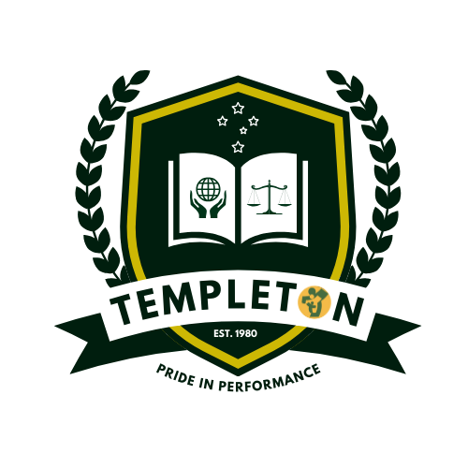

Science


Help for non-English speakers
If you need help to understand the information in this policy, please contact Xiaomei Lin 9801 7450

Rationale

There is a diversity of world views which should be welcomed, valued, and respected. Science empowers students to be questioning, reflective and critical thinkers.

Aims

Through exploratory and purposeful play, students in Years Prep – 2 will be involved in Science
learning activities that focus on their awareness of self and the local world. In this age range the aims of the Science Program is to foster skills in:

Exploration
Observation
Order
Change
Questioning and speculation

Students in Years Prep to 6 will have opportunities to develop ideas about Science that relate to their life and living. The aims of the Science Program at this level are to introduce a broader range of scientific concepts that will be explored by building on unifying ideas of exploration, observation, order, change, reason, and speculation. These concepts will include:

Patterns Systems
Cause and effect
Evidence and explanation

Implementation

All teachers will utilise the E5 model of Engage, Explore, Explain, Elaborate, Evaluate and other relevant resources to implement an effective Science program for all students, based on the progression points contained within the Victorian Curriculum.

The assessment indicators contained in the Victorian Curriculum will be addressed by work samples, common assessment tasks and moderation to provide evidence of developmental outcomes and formal reporting judgements.

Science will be integrated into the English and Maths curriculum where appropriate.

Science will be taught across P-6 during the second semester as a compact course, sometimes conducted by incursion. In Years 3-6, all relevant standards will be met and reported to parents in December reports.

The Science Committee will promote and support community partnership programs that assist teachers to enhance students’ Science education outcomes. These may include, for example, “Scientists in Schools”, CSIRO Quest Awards, STAV Science Talent Search, STAV Science Drama Awards and Victorian Solar Boat Challenge.

A budget that provides for the needs of the Science Program will be developed by staff and resourced by School Council.

Evaluation

This policy will be reviewed in accordance with the school’s three-year review cycle.

Last ratified by School Council in September 2025

