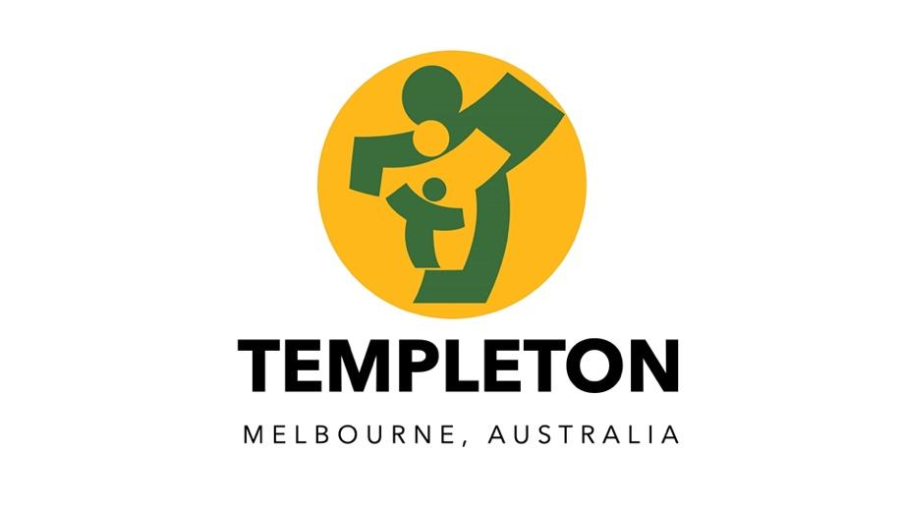

Visual & Performing Arts

Rationale

Visual and Performing Arts are practised and valued in our complex and diverse society as important outlets for the communication of ideas, feelings and beliefs and as major sources of intellectual, physical, spiritual, and emotional development, understanding and enjoyment.

Aims

The Visual and Performing Arts Programs will nurture in children an enjoyment and understanding of the Arts and foster creativity which may enrich the quality of their lives and provide further avenues for effective use of leisure time.

Through our program students:

Develop their intellectual, imaginative, and expressive potential

Develop skills, techniques, and a knowledge of processes as a basis for personal expression

Create, perform, or present arts works

Develop critical skills and an understanding of aesthetics

Develop understanding of how the arts evolve within social, cultural, and historical contexts

Achieve personal satisfaction through artistic achievement and develop confidence and a positive self-image through success.
.
Implementation

All students at Templeton will experience Art, Music, Dance, Drama, Media, and Visual Communication activities based upon outcomes in the Victorian Curriculum

The school employs specialist teachers who are responsible for Visual and Performing Arts

Instrumental music teachers offer private tuition to students whose parents wish to pay for the service.

Student progress in all strands of the Arts, will be reported June and December academic reports.

Budgets that provide for the needs of the various Arts programs will be developed by Visual and Performing Arts staff and resourced by School Council.

Evaluation

This policy will be reviewed in accordance with the school’s three-year review cycle.

Last ratified by School Council in September 2022

