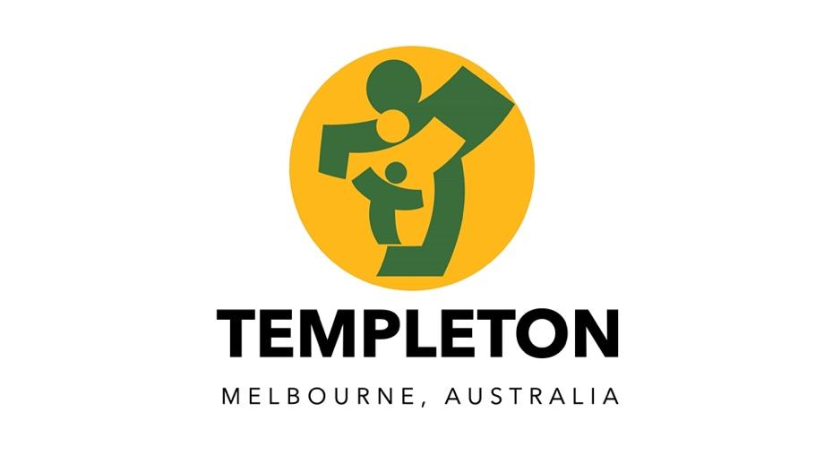

School Uniform

Help for non-English speakers
If you need help to understand the information in this policy, please contact Xiaomei Lin 9801 7450

Rationale
According to the Department of Education and Training, Templeton Primary School Council has the authority to develop and implement dress codes for their students as outlined in legislation relating to dress codes.

Schools work with their school communities in:
- Developing and reviewing dress codes
- Implementing and enforcing dress codes.

All dress codes must meet:
- Human rights and anti-discrimination requirements
- Include an exemption process
- Health and safety considerations
- Requirements relating to uniform supply arrangements.

Schools also work with the State Schools' Relief to support students in need as well as supporting fundraising activities.

By accepting an offer of enrolment at Templeton, parents agree to adhere to the Uniform Policy and sign an agreement at the beginning of each school year confirming their commitment to our Uniform Policy.

Purpose
- Promoting a sense of identity, pride, cohesion, and good order in the school
- Allowing all students to feel equal
- Preventing bullying and competition based on clothing
- Ensuring students’ appearance reflects the expectations of their school community
- Enhancing the profile and identity of the school and its students within the wider community
- Strengthening the spirit of community within the school
- Enhancing individual student safety and group security
- Ensuring all students are dressed safely and appropriately for school activities
- Encouraging students to develop pride in their appearance
- Preparing students for the expectations of workplaces
- Encouraging students to present themselves appropriately for a particular role.

Responsibilities of School Council

- Deciding on arrangements for the supply of school uniform items
- Compliance with written agreements with clothing suppliers and may be subject to legal proceedings if a dispute arises between the parties
- Must not make any misrepresentations while making agreements with suppliers (for example, misrepresenting the number of students at the school).
- Costs
- Quality of items
- Quality control of the supplier
- Reliability, continuity, and lead time of supply
- Ability of manufacturers/suppliers to meet required delivery deadlines
- Selecting Australian made items or using local businesses
- Sustainable production of items
- How and where parents or carers can purchase items
- Returns policy for faulty stock
- Re-use or recycling of items
- Ensure all students adhere to wearing only school approved uniform items.

Licence
Templeton Primary School has licensed a supplier to sell the uniform from a designated area on the school premises. The Templeton Primary School Uniform Policy applies to all children during school hours, while travelling to and from school and excursions, as stated in the Uniform Policy.
Only uniform items available for purchase from our Uniform Shop are school approved. School Council does not approve items purchased from other outlets.

Standard Uniform

Bottle green tracksuit pants or bootleg pants
Bottle green gabardine shorts and pants
Bottle green and gold rugby windcheater with school logo
Bottle green polar fleece jacket with school logo
Bottle green and gold bomber jacket with school logo
Templeton tartan skirt or tunic
Bottle green and white check dress
Bottle green tights
Bottle green scarves
Gold polo shirt – short and long sleeved with school logo
Green and gold waterproof jacket
Bottle green waterproof jacket
*Year 6 students may purchase and wear a unique Templeton hooded windcheater in their final year.

Hats

Bottle green flap cap with school logo
Bottle green baseball cap with school logo
Bottle green bucket hat with school logo
Bottle green beanie with school logo
*Hats mandated in Term 1 and 4.

Footwear

Plain white socks always worn
No logos permitted
Shoes are restricted to black lace-up or buckle and sturdy pull-on shoes for safety.

School Bag

Bottle green school bag with school logo

Physical Education Year P-4

School uniform worn for all Physical Education lessons Year Prep-4
Runners or sneakers permitted on day of Physical Education lesson
Sports briefs under dresses for girls or green/black bike shorts.

Physical Education Year 5/6

Templeton Sports Uniform may be worn:

5/6 sport on Fridays

5/6 Interschool Sport days

Special sports days (Athletics, Swimming, Cross Country, Hoop Time etc.)

Regular school uniform must be worn by 5/6 students if their Physical Education lesson is scheduled Monday-Thursday

Runners or sneakers permitted on day of Physical Education lesson
Sports briefs under dresses for girls or green/black bike shorts
Year 5/6 lightweight green sports shorts
Year 5/6 lightweight sports t-shirt with school logo.

Not Permitted
- Uniform items purchased at outlets other than our school uniform shop.
- Outerwear not consistent with school colours.
- Socks or shoes with visible logos.
- Jewellery (only exceptions are plain stud or small sleeper earrings and jewellery for religious reasons).
- Leggings.
- Coloured hair spray, dyed hair that is not a natural colour.
- Hair:
  - Spikes, Mohawks, ‘Rat’s Tails’ and shaved patterns and lines.
  - For health and safety reasons, hair that exceeds shoulder length must be tied back.
  - Hair accessories are limited to yellow, green, or neutral colours.
- Body piercings (boys and girls ear piercings are limited to plain studs).
- Make-up and other cosmetics (clear nail polish permitted).
- Hats/Beanies when inside.

Implementation:

- Uniform Policy implemented in a manner consistent with the Student Code of Conduct
- Parents seeking exemptions to the Uniform Policy may contact the Principal in writing
- Assistance is available to parents who need support to meet the cost of the uniform. Parents are asked to contact the Principal or Business Manager to discuss their situation and arrange a payment plan
- Uniform Policy implemented at the discretion of the Principal.

Evaluation

This policy will be reviewed in accordance with the school’s three-year review cycle.

Last ratified by School Council in September 2022

